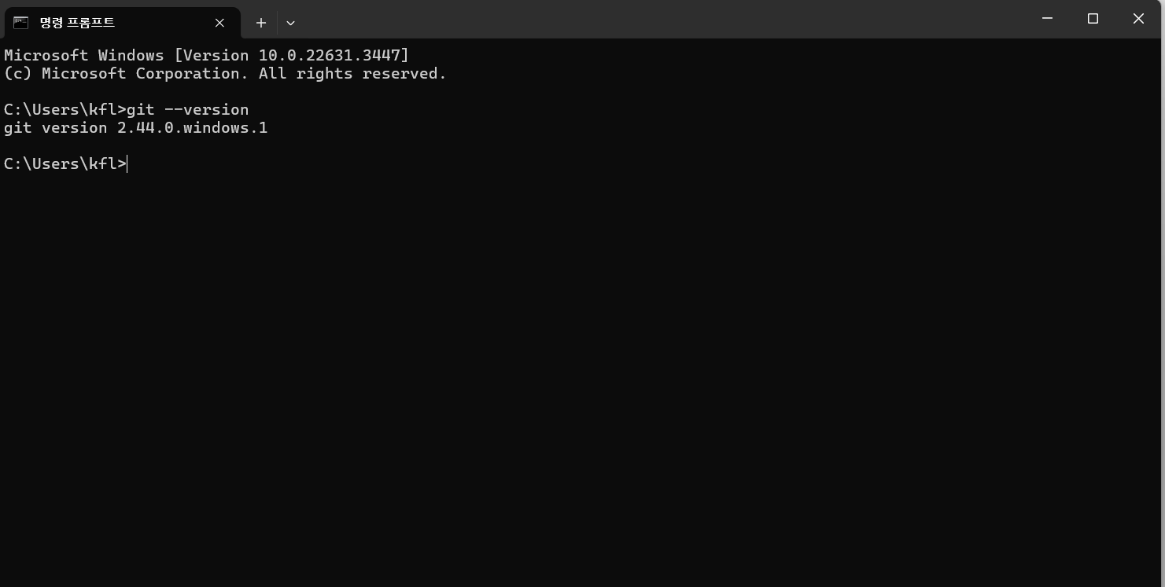

[JBTHEO/JBTHEO (github.com)](https://github.com/JBTHEO/JBTHEO)

<https://github.com/JBTHEO/JBTHEO.git>